Tutorial 1 – Basics of ROS 2

Exercise 1.1 - Making the first ROS 2 workspace.
Firstly, the user can decide to a create directory using the user interface or via a shell terminal.
For user interface:
- User may use right-click to create a new folder with any name of preference. This folder will be the workspace.

- Enter the workspace created and create a folder named src .
For shell terminal:
- Open the terminal and use the command
$ mkdir workspace name
To check if the workspace has been created, type the command $ ls and a list of files and folder should appear. Folder type directory should appear blue.

- Enter the folder using the command
$ cd workspace name
To check if entered the folder correctly, the command line should reflect the home directory and in addition a text of: ~/workspace name

- Repeat Step 1 within your new workspace to create a folder called src

- Once done, proceed to build your workspace using the command below:
$ colcon build
If the build is successful, there should be 3 new folders created; build, install and log.
Finally, to source the new setup using the command:
$ source install/local_setup.bash
This command allows the system to recognize the path into packages within this workspace. When there is a new package added into this workspace, use this command after colcon build was used to reconfigure the paths.
NOTE: The source command for the workspace has to be run at the workspace level (i.e. the directory before entering the src, devel or build folder.)
Exercise 1.2 – Creating the first ROS package.
ROS 2 packages are where different nodes are stored and may be executed to perform different tasks. To create ROS 2 package, it may be done by importing packages from open sources or via the ros2 pkg create command.
For importing packages from open sources:
- Find the source files from github and use the command to clone the package within your src folder:
$ git clone -b foxy-devel link of package
link : https://github.com/ROBOTIS-GIT/turtlebot3.git
This link will install all the necessary packages required to use the turtlebot3 in this bootcamp.

To create a new ros package:
- Enter the src folder within the workspace and use the command:
$ ros2 pkg create --build-type ament_python <package_name>

Once the package has been created, build and source your workspace.
Note: building and sourcing of workspace should be done within the parent directory of your workspace
Check the package and it should contain the following; (1) src folder (2) CMakeLists.txt and (3) package.xml.
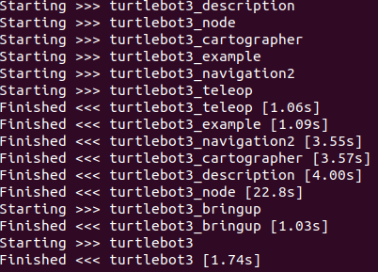
Figure 1. Successful colcon build example
*************************************************************************************To ensure the workspace is sourced with the packages previously use the command $source install/local_setup.bash edit the .bashrc file from home using the command:
$ gedit .bashrc

After which, add these two lines to the bottom of the file and save all changes.
source /opt/ros/foxy/setup.bash
source ~/ros2_bootcamp/install/setup.bash

Once completed, re-source the newly edited bashrc file with the following command:
$ source ~/.bashrc
Now, the computer will now recognize the packages in the workspace each time a terminal is started.
*************************************************************************************

Exercise 1.3 – Installing ROS packages/dependencies
In a workspace, you will need to resolve dependencies and ensure all dependencies are installed, you would have to do this in the root of your workspace (cd workspacename).
$ rosdep install -i --from-path src --rosdistro foxy -y
To test if the turtlesim package has been installed correctly:
First, run the following command to view all the executable files installed for turtlesim:
$ ros2 pkg executables turtlesim

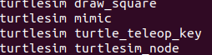
Figure 2. List of executables for turtlesim

Next, start the turtlesim node using the following command:
$ ros2 run turtlesim turtlesim_node
A small user-interface with a turtle should pop-out.
To control the turtle, use a different terminal and start the ROS node:
$ ros2 run turtlesim turtle_teleop_key
You should now be able to control the turtle using the arrows on your keyboard.
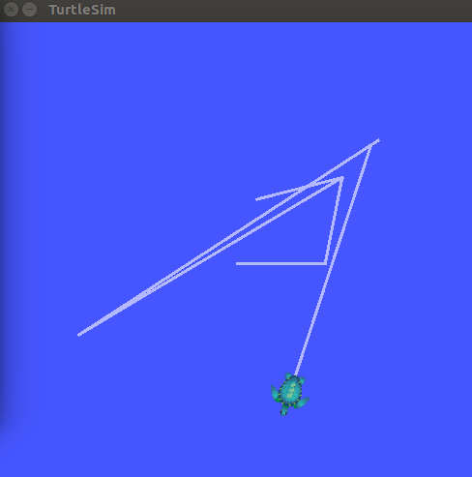
Figure 3. A turtlesim GUI.
Exercise 1.4 – ROS 2 Publisher and Subscriber
This exercise would help user obtain information from running ROS nodes and publish command to the nodes.
- ROS 2 Topic
To check the ROS topic which are running, use the command (in a new tab):
$ ros2 topic list
To view the topic’s livestream data, use the command:
$ ros2 topic echo /topic_name

- ROS 2 Info
This command would bring out a list of topics currently being subscribed or published to. To view the topic type and its current subscriber/publisher, use the command:
$ ros2 topic info /topic_name
Alternatively, view all the topics which the running nodes are publishing/subscribing to using the command:
$ ros2 node info /node_name

- ROS 2 Topic type
Next, the topic types may be accessed using the command:
$ ros2 topic list -t [TOPIC TYPES ARE SHOWN IN BRACKETS]

- First Script
To write the first publisher and subscriber, use the steps from previous exercises to create an empty package within your src folder with a dependency of rclpy
Next, create a python script in the package’s src folder. For the system to recognize a python script, all python script shall have the header: #!/usr/bin/env python

Creating a subscriber to the current position of the turtlesim
#!/usr/bin/env python

#Importing Main Libraries
import rclpy
from rclpy.node import Node
from geometry_msgs.msg import Twist

class MinimalSubscriber(Node):

def __init__(self):
super().__init__('py_sub_spiral_node')
self.subscriber_ = self.create_subscription(Twist, 'turtle1/cmd_vel', self.subscribe_message, 1)
self.subscriber_ # prevent unused variable warning

def subscribe_message(self, msg):
self.get_logger().info('Recieved - Linear Velocity : %f, Angular Velocity : %f' % (msg.linear.x, msg.angular.z))

def main(args=None):
rclpy.init(args=args)
minimal_subscriber = MinimalSubscriber()
rclpy.spin(minimal_subscriber)
minimal_subscriber.destroy_node()
rclpy.shutdown()

if __name__ == '__main__':
main()

Creating a publisher to the send velocity command to the turtlesim
#!/usr/bin/env python
import sys
import rclpy
from rclpy.node import Node
from geometry_msgs.msg import Twist

class MinimalPublisher(Node):

def __init__(self):
super().__init__('py_pub_spiral_node')
self.publisher_ = self.create_publisher(Twist, 'turtle1/cmd_vel', 1)
timer_period = 0.5 # seconds
self.i = 0.0
self.timer_ = self.create_timer(timer_period, self.publish_message)

def publish_message(self):
message = Twist()
message.linear.x = float(sys.argv[1])
#message.angular.z = float(sys.argv[2]) + self.i
self.get_logger().info('Sending - Linear Velocity : %f, Angular Velocity : %f' % (message.linear.x, message.angular.z))
self.publisher_.publish(message)
self.i += float(sys.argv[3])

def main(args=None):
rclpy.init(args=args)
minimal_publisher = MinimalPublisher()
rclpy.spin(minimal_publisher)
minimal_publisher.destroy_node()
rclpy.shutdown()

if __name__ == '__main__':
main()

In package.xml add:
<exec_depend>geometry_msgs</exec_depend>
In setup.py, add the console scripts:
'console_scripts': [ 'pub_spiral = py_sub.pub_spiral:main',
'sub_spiral = py_sub.sub_spiral:main;]

To execute a standalone python script, access must be given to the script using the command:
$ chmod +x ./name of the python script

To execute the python script:
$ ros2 run py_sub pub_spiral 2.0 2.0 0.2

Additional Exercise
Merge the publisher and subscriber node into a single script and write an if/else condition to allow the turtlesim stop before colliding to the boundary.

This folder has to have the exact name for ROS 2 to recognize this workspace.
The cloning has to be done within the workspace’s src folder.

